Assignment No: 9

Title: Introduction to Arduino Board and Installation of Raspbian OS.

Objective:
To study Arduino kit in detail along with installation of Raspbian OS.

Problem Statement: Study of Arduino Board and understand the OS installation Process on Raspberry-Pi..

Course Outcome:

C214455.IV: Use source prototype platform like Raspberry-Pi/Beagle board/Arduino
Blooms Taxonomy Category: Applying

Arduino kit :

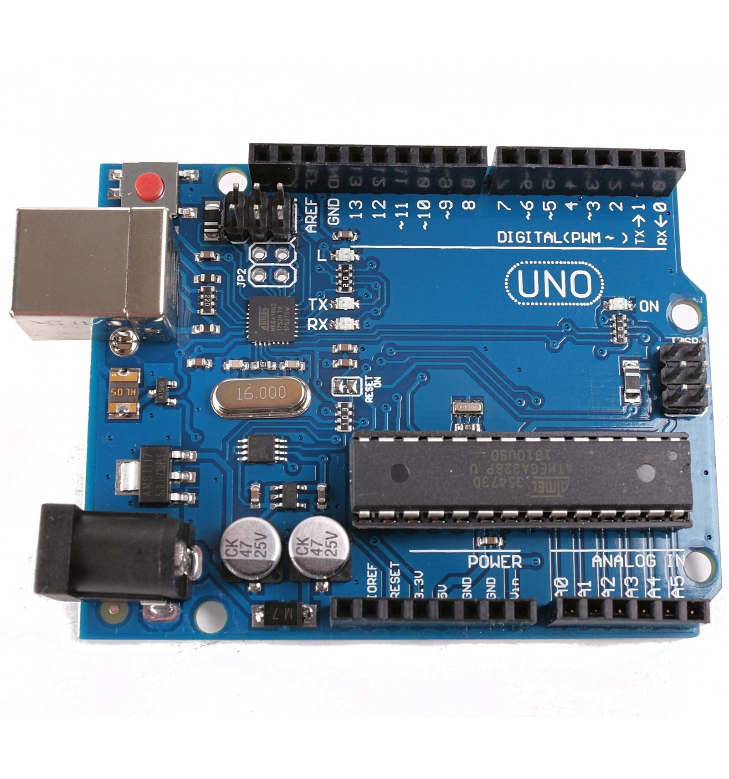
- Raspberry kit :
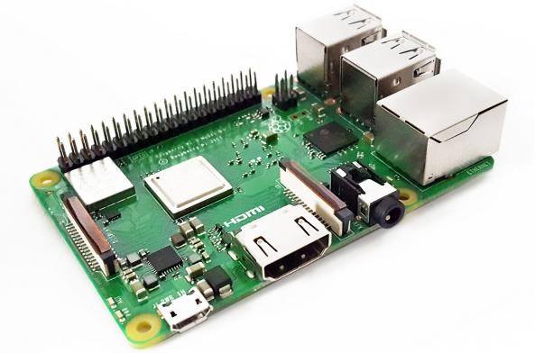

Steps of Installation of OS :

- Download and Install the Raspberry Pi Imager application

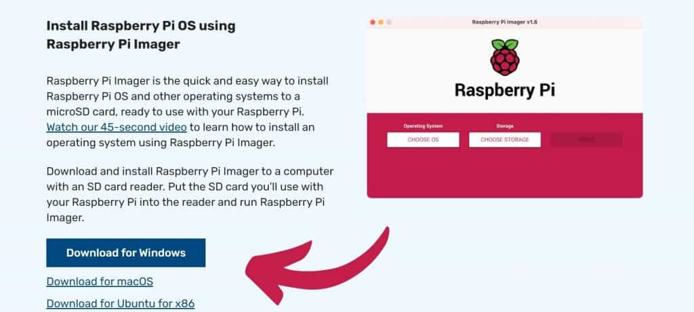
- Run the Raspberry Pi Imager application
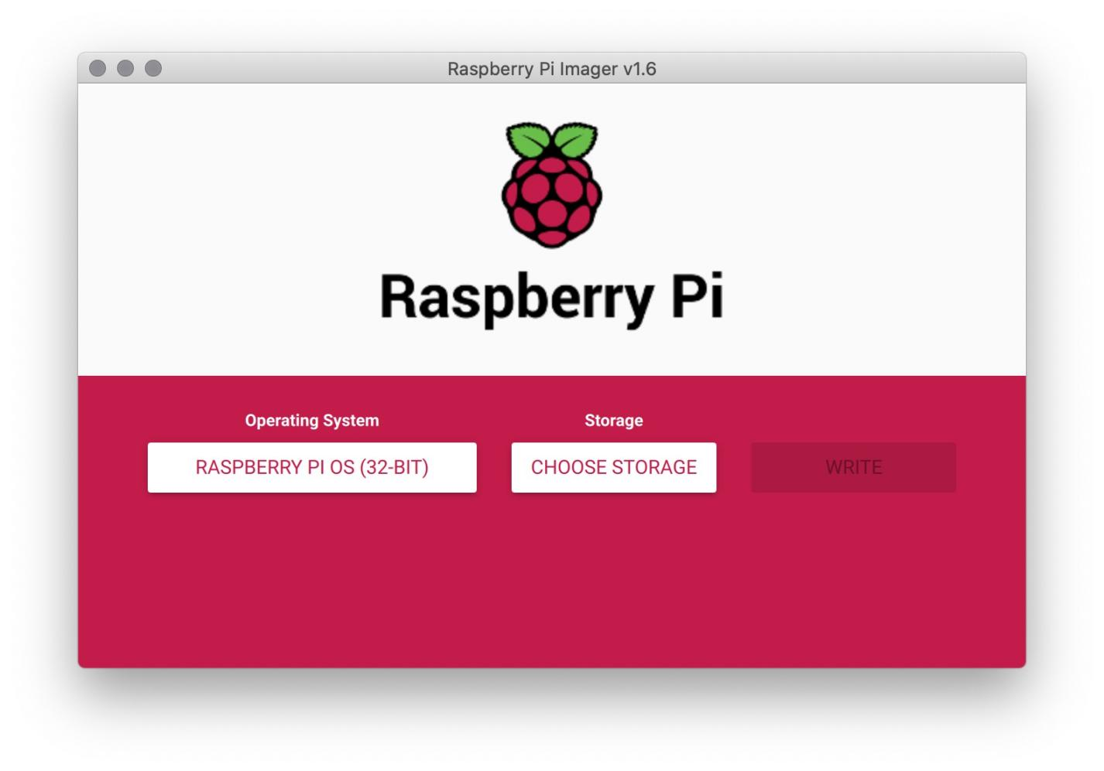
- Choose Raspberry Pi OS Image on the Raspberry Pi

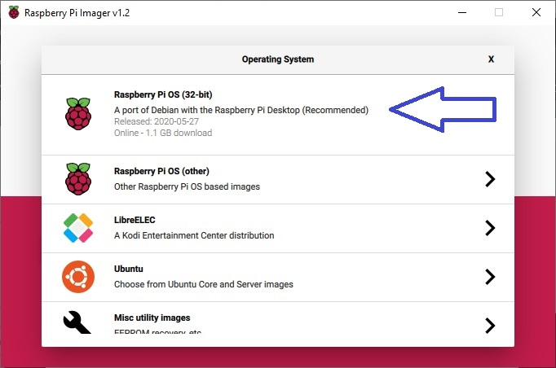

4 ) Choose the Storage

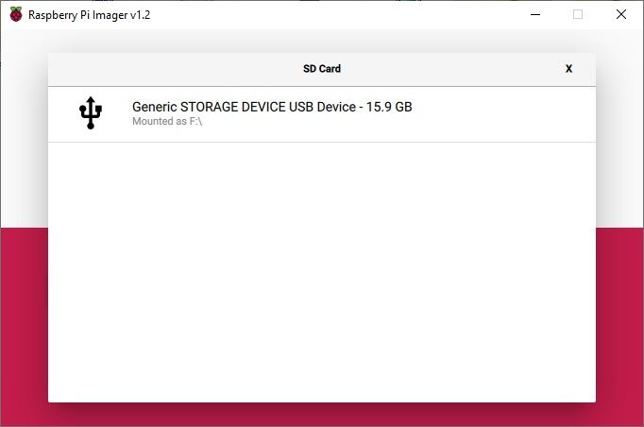

- Write the Raspberry Pi OS image to the storage

- Raspberry Pi OS image is being written to the USB storage

- Raspberry Pi OS image is being veriﬁed

- Raspberry Pi OS image

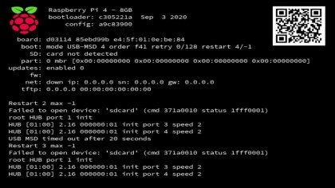
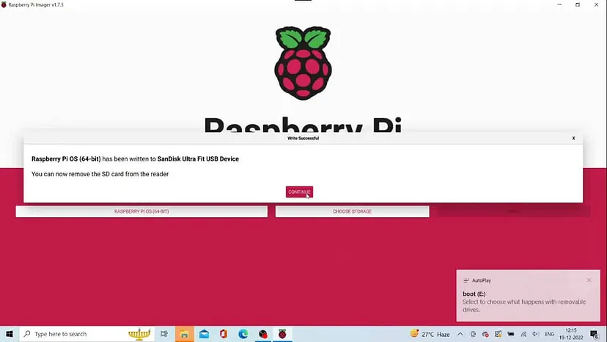is written to the USB storage drive

- Boot the Raspberry Pi inserting the USB drive

- The colored window of Raspberry Pi

- Boot the Raspberry Pi inserting the USB drive

- The colored window of Raspberry Pi


- Raspberry Pi OS is in the boot process
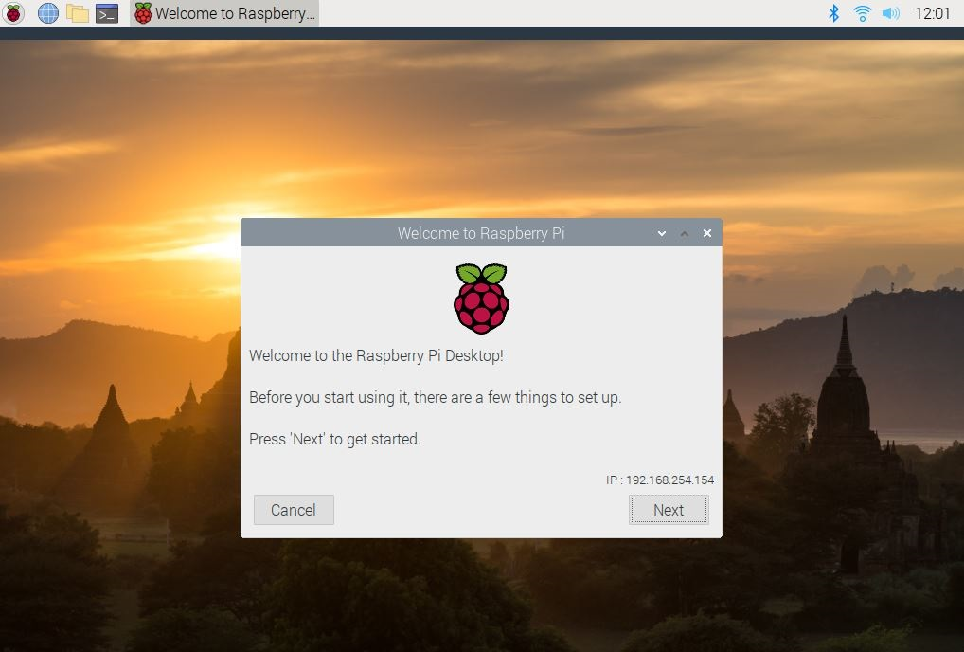

- ) System Conﬁguration Wizard
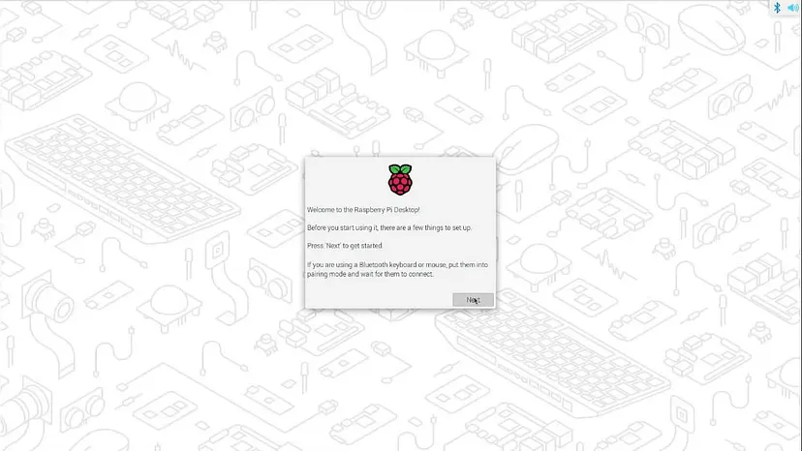

- ) Reboot the Raspberry Pi
14) Raspberry Pi OS is running on the Raspberry 